**KEY MILESTONE: 1**

**DONATION MANAGEMENT SYSTEM**



**Spring 2025**

**Database Management Lab**

Submitted by:

**Nouman Khan (22PWCSE2107)**

**Tariq Jamil (22PWCSE2184)**

**Mahran Khan (22PWCSE2185)**

ClassSection **: A**

Submitted to:

**Engr. Summayea Salahuddin**

July 08, 2025

**Department of Computer Systems Engineering**

**University of Engineering and Technology, Peshawar**

**DONATION MANAGEMENT SYSYEM**

**Entity Description:**

|  |  |
| --- | --- |
| **Entity** | **Description** |
| **DONOR** | A person or organization that makes one or more donations to the system. |
| **DONATION** | A record of a gift (money or items) given by a Donor, including amount, date, payment mode, and purpose. |
| **DONATION_PROOF_PENDING** | A record of the donations made by the donors which are not yet approved by the ADMIN_USER |
| **FUNDRAISING_EVENT** | An organized campaign or event held to collect donations toward a particular cause, with a target amount and date/location. |
| **EVENT_DONATION** | A linking (junction) record that associates a specific Donation with a specific Fundraising Event. |
| **DISTRIBUTION_REPORT** | A summary of how and when donated funds or items were disbursed or allocated to beneficiaries. |
| **VOLUNTEER_DISTRIBUTE** | A person who is tasked up to help with distributing donations, tracked by VolunteerDistID, loginID contact info and role etc. |
| **VOLUNTEER_TASK** | A person who is tasked up to help with events, tracked by VolunteerEvtID, loginID contact info and role etc. |
| **ADMIN_USER** | A system user with elevated privileges to manage donors, events, donations, volunteers, and distribution reports. |

**Business Rules:**

**1. User Roles:**

* Admin: Manages donors, donations, events, volunteers, and verifies donations.
* Donor: Registers, logs in, donates, and submits proof of donation.
* Volunteer: Registers, logs in, and is assigned to events or distribution tasks.

**2. Donor Management:**

* Donor Registration: Donors can register and log in.
* Donor-Donation Relationship: One-to-Many One donor can make many donations.
* Admin-Donor Relationship: One-to-Many One admin can manage many donors.

**3. Donation Management**

* Donation Submission: Donors submit donations, each requiring proof.
* Donation-Donor Relationship: Many-to-One Many donations belong to one donor.
* Donation Proof: One-to-One: Each donation has one proof of donation (pending until verified).
* Admin-Donation Relationship: One-to-Many: One admin can verify many donations.

**4. Event Management**

* Event Creation: Admins create and manage fundraising events.
* Event-Volunteer Relationship: Many-to-Many: An event can have many volunteers as staff, and a volunteer can serve at many events (via `volunteer_eventstaff` table).

**5. Volunteer Management**

* Volunteer Registration: Volunteers can be registered by admin and they can log in.
* Volunteer Assignment: Many-to-Many Volunteers can be assigned to many distribution tasks, and a distribution task can have many volunteers (via `volunteer_distribute` table).
* Admin-Volunteer Relationship: One-to-Many One admin can manage many volunteers.

**6. Distribution Management**

* Distribution Task Assignment: Many-to-Many Distribution tasks can have many volunteers, and volunteers can be assigned to many tasks.
* Distribution Completion: Each assignment can be marked as completed.

**7. Authentication & Authorization**

* User-Profile Relationship: One-to-One Each user has one profile.
* Admin Authentication: Protected by middleware.

**8. Email Notifications**

* Triggered by Events: Donation approval, donor registration, volunteer creation, and task assignment trigger emails.

**9. Data Integrity & Security**

* Access Control: Only admins can manage (create, update, delete) donors, donations, events, and volunteers.
* Donors and volunteers can only access their own data.

**10. Reporting & Accountability**

* Admin-Report Relationship: One-to-Many Admin can view many reports (on distributions, donations, donors, volunteers).

**12. Public Pages**

Accessible to All: Home, About, Contact, and Welcome page

**Conceptual Schema (ERD):**

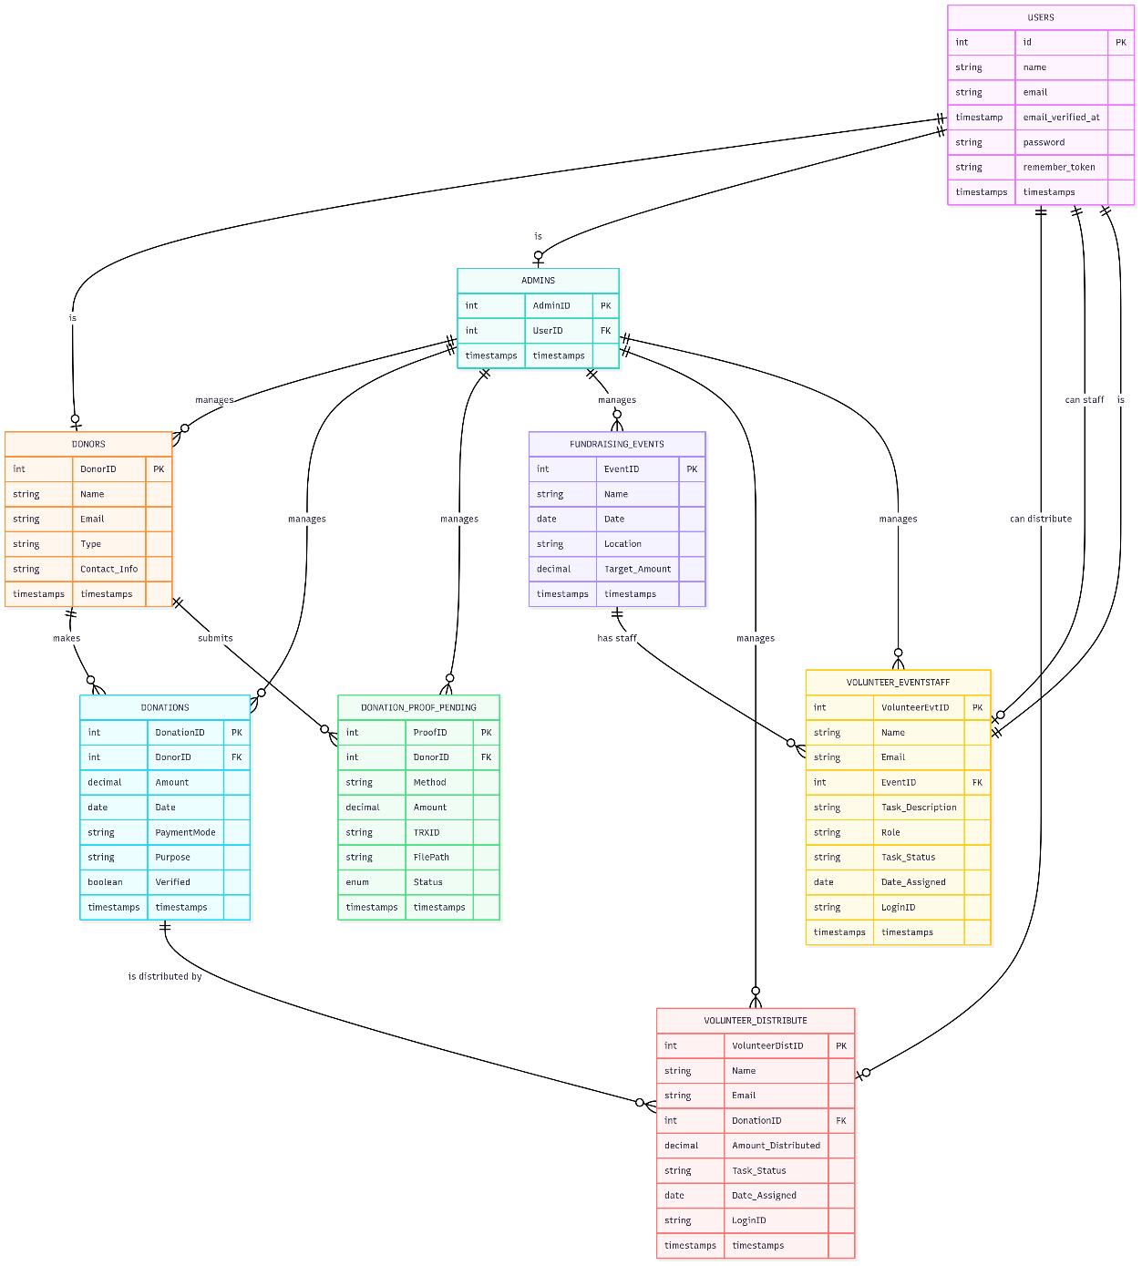

**References:**

* DBMS Lecture 2b Slides
* OpenAI ChatGPT.
* draw.io, <https://app.diagrams.net>